Epoch = 100

Epoch = 200

Epoch = 290

Epoch = 300

Epoch = 311

Epoch = 356

Epoch = 500

Epoch = 800

Epoch = 1,000

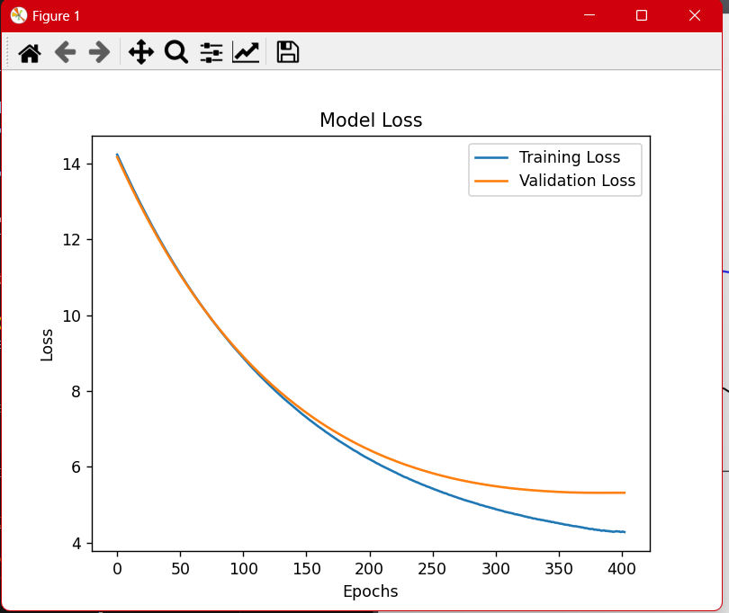

import json

import numpy as np

from tensorflow.keras.optimizers import Adam

from tensorflow.keras.models import Sequential

from tensorflow.keras.layers import Embedding, LSTM, Dense, Dropout

from tensorflow.keras.preprocessing.text import Tokenizer

from tensorflow.keras.preprocessing.sequence import pad_sequences

from sklearn.model_selection import train_test_split

from tensorflow.keras.callbacks import ReduceLROnPlateau, ModelCheckpoint, EarlyStopping

from tensorflow.keras.regularizers import l2

import matplotlib.pyplot as plt

# Load data

def load_data():

    with open('data/sentences_data.json', 'r', encoding='utf-8') as f:

        data = json.load(f)

    texts = [d['thai'] for d in data['sentences']]

    labels = [d['id'] - 1 for d in data['sentences']]  # Adjust labels to start from 0

    return texts, labels

# Prepare data for training

def prepare_data(texts, labels):

    tokenizer = Tokenizer()

    tokenizer.fit_on_texts(texts)

    sequences = tokenizer.texts_to_sequences(texts)

    word_index = tokenizer.word_index

    X = pad_sequences(sequences, padding='post')

    y = np.array(labels)

    # Save the tokenizer

    tokenizer_json = tokenizer.to_json()

    with open('data/tokenizer.json', 'w', encoding='utf-8') as f:

        f.write(tokenizer_json)

    return X, y, tokenizer

# Build the model

def build_model(vocab_size, max_length, output_dim):

    model = Sequential([

        Embedding(vocab_size, 256, input_length=max_length),

        LSTM(256, return_sequences=True, kernel_regularizer='l2'),

        Dropout(0.5),

        LSTM(128, return_sequences=True, kernel_regularizer='l2'),

        Dropout(0.5),

        LSTM(64, kernel_regularizer='l2'),

        Dense(128, activation='relu', kernel_regularizer='l2'),

        Dropout(0.5),

        Dense(output_dim, activation='softmax')

    ])

    optimizer = Adam(learning_rate=0.0001)  # ลด learning rate

    model.compile(optimizer=optimizer, loss='sparse_categorical_crossentropy', metrics=['accuracy'])

    return model

# Check if the model predictions are correct

def check_accuracy(model, X, y):

    predictions = model.predict(X)

    predicted_labels = np.argmax(predictions, axis=1)

    true_labels = y

    accuracy = np.mean(predicted_labels == true_labels)

    print(f"Predictions: {predicted_labels[:5]}, True Labels: {true_labels[:5]}")

    return accuracy

# Main training function

def train_model():

    texts, labels = load_data()

    X, y, tokenizer = prepare_data(texts, labels)

    print("Sample X:", X[:5])

    print("Sample y:", y[:5])

    max_length = X.shape[1]

    vocab_size = len(tokenizer.word_index) + 1

    output_dim = len(set(labels))

    model = build_model(vocab_size, max_length, output_dim)

    X_train, X_test, y_train, y_test = train_test_split(X, y, test_size=0.2, random_state=55)

    # Callbacks

    reduce_lr = ReduceLROnPlateau(monitor='val_loss', factor=0.5, patience=20, min_lr=0.00001)

    model_checkpoint = ModelCheckpoint('models/best_video_selection_model.keras', monitor='val_loss', save_best_only=True, mode='min')

    early_stopping = EarlyStopping(monitor='val_loss', patience=100, restore_best_weights=True)

    # Training with 3000 epochs and batch size 32

    history = model.fit(X_train, y_train, epochs=3000, batch_size=32, validation_data=(X_test, y_test), callbacks=[reduce_lr, model_checkpoint, early_stopping])

    # Check accuracy after initial training

    current_accuracy = check_accuracy(model, X_test, y_test)

    print(f"Initial accuracy: {current_accuracy}")

    # Save the final model

    model.save('models/video_selection_model_final.keras')

    # Plotting the loss

    plt.plot(history.history['loss'], label='Training Loss')

    plt.plot(history.history['val_loss'], label='Validation Loss')

    plt.title('Model Loss')

    plt.xlabel('Epochs')

    plt.ylabel('Loss')

    plt.legend()

    plt.show()

if __name__ == "__main__":

    train_model()

